

***System Provisioning and Configuration Management***

***Submitted by:***

***NAME: Tanishqua Tellakula***

***SAP ID: 500084269***

***Roll number: R120220007***

***Batch: B1(Hons)***

***EXPERIMENT 4***

***Provisioning an EC2 Instance on AWS***

***Prerequisites:*** *Terraform Installed: Make sure you have Terraform installed on your machine. Follow the official installation guide if needed.*

***AWS Credentials:*** *Ensure you have AWS credentials (Access Key ID and Secret Access Key) configured. You can set them up using the AWS CLI or by setting environment variables.*

***Exercise Steps:***

***Step 1: Create a New Directory:***

*Create a new directory for your Terraform configuration:*

| *Terraform-Demo* |
| --- |

***Step 2: Create Terraform Configuration File (main.tf):***

*Create a file named main.tf with the following content*

| ***terraform {***  ***required_providers {***  ***aws = {***  ***source = "hashicorp/aws"***  ***version = "5.34.0"***  ***}***  ***}***  ***}***  ***provider "aws" {***  ***region = "ap-south-1"***  ***access_key = "your IAM access key"***  ***secret_key = "your secret access key"***  ***}*** |
| --- |

*This script defines an AWS provider and provisions an EC2 instance.*

***Step 3: Initialize Terraform:***

*Run the following command to initialize your Terraform working directory:*

***terraform init***

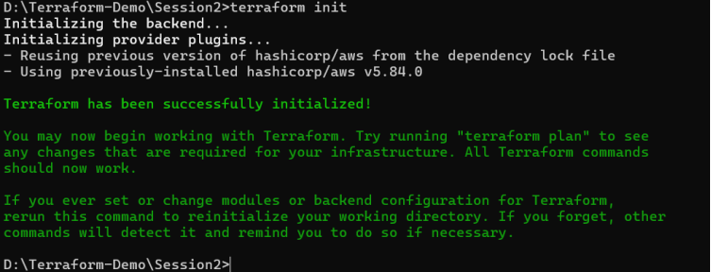

***Step 4: Create Terraform Configuration File for EC2 instance (instance.tf):***

*Create a file named instnace.tf with the following content:*

***resource "aws_instance" "My-instance" {***

***ami = "ami-03f4878755434977f"***

***instance_type = "t2.micro"***

***tags = {***

***Name = "UPES-EC2-Instnace"***

***}***

***}***

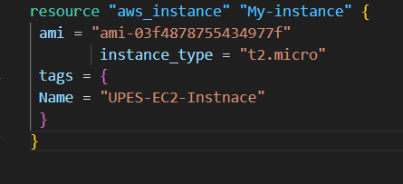

***Step 5: Review Plan:***

*Run the following command to see what Terraform will do:*

***terraform plan***

*Review the plan to ensure it aligns with your expectations.*

***Step 6: Apply Changes:***

*Apply the changes to create the AWS resources:*

***terraform apply***

*Type yes when prompted.*

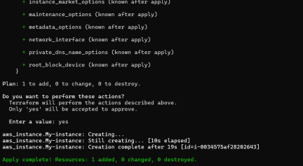

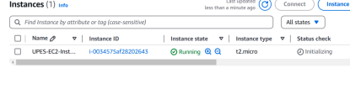

***Step 7: Verify Resources:***

*After the terraform apply command completes, log in to your AWS Management Console and navigate to the EC2 dashboard. Verify that the EC2 instance has been created.*

***Step 8: Cleanup Resources:***

*When you are done experimenting, run the following command to destroy the created resources:*

***terraform destroy***

*Type yes when prompted.*

*Notes:*

*Customize the instance.tf file to provision different AWS resources.*

*Explore the Terraform AWS provider documentation for additional AWS resources and configuration options.*

*Always be cautious when running terraform destroy to avoid accidental resource deletion.*

*This exercise provides a basic introduction to using Terraform with the AWS provider. Feel free to explore more complex Terraform configurations and resources based on your needs.*

